Algorithm Analysis Fundamentals
Time complexity analysis of iterative and recursive algorithms; verify Big-O, Ω, Θ for sample programs
Dr. M.Manikandan

Experiment 1: Linear Search (Iterative)
- Objective: To analyze time complexity of linear search.
- Problem Statement: Write a Python program to search for a key in an array using linear search.
- Sample Input: [10, 25, 30, 45, 50], Key = 30
- Sample Output: Key found at index 2
- Complexity: Ω: O(1), O: O(n), Θ: Θ(n)
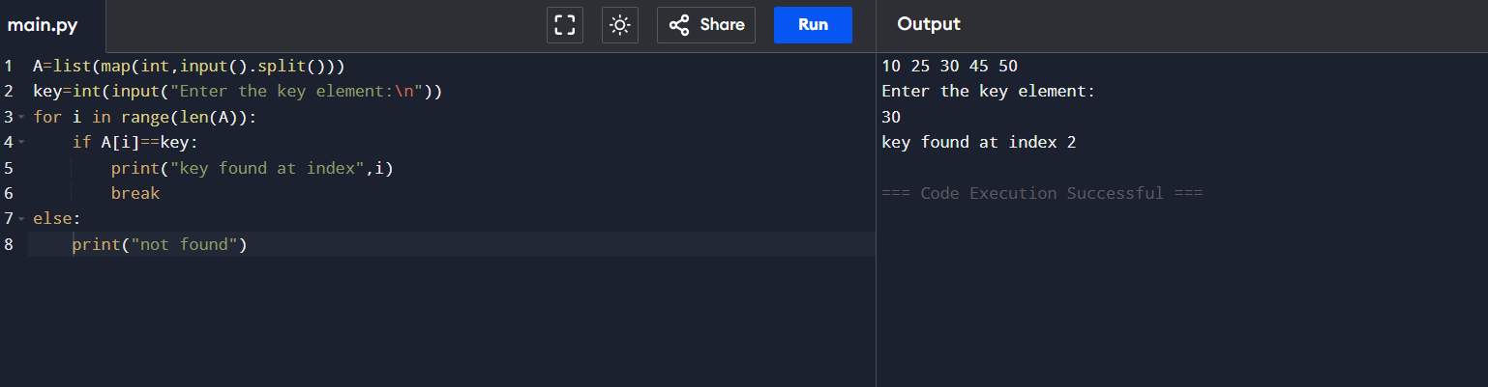
- Explanation: Demonstrates sequential scanning and inefficiency for large inputs.

Experiment 2: Binary Search (Recursive)
- Objective: To compare recursive binary search complexity.
- Problem Statement: Implement recursive binary search in Python.
- Sample Input: [5, 10, 15, 20, 25], Key = 20
- Sample Output: Key found at index 3
- Complexity: Ω: O(1), O: O(log⁡n), Θ: Θ(log⁡n)
- Explanation: Shows divide-and-conquer and logarithmic efficiency.
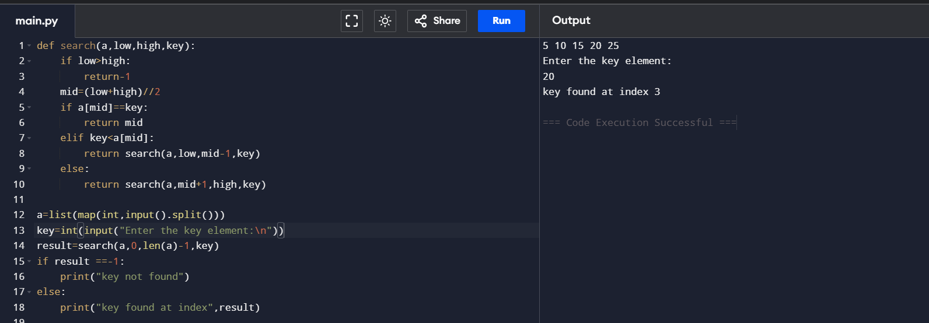

Experiment 3: Factorial (Iterative vs Recursive)
- Objective: To compare iterative and recursive factorial computation.
- Problem Statement: Write programs to compute factorial using both methods.
- Sample Input: n = 5
- Sample Output: 120
- Complexity: Both O(n)
- Explanation: Highlights recursion depth vs iterative loops.

ITERATIVE METHOD
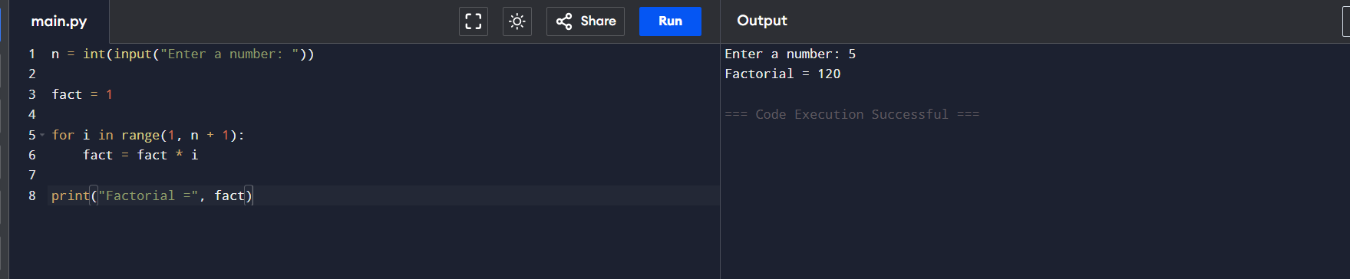

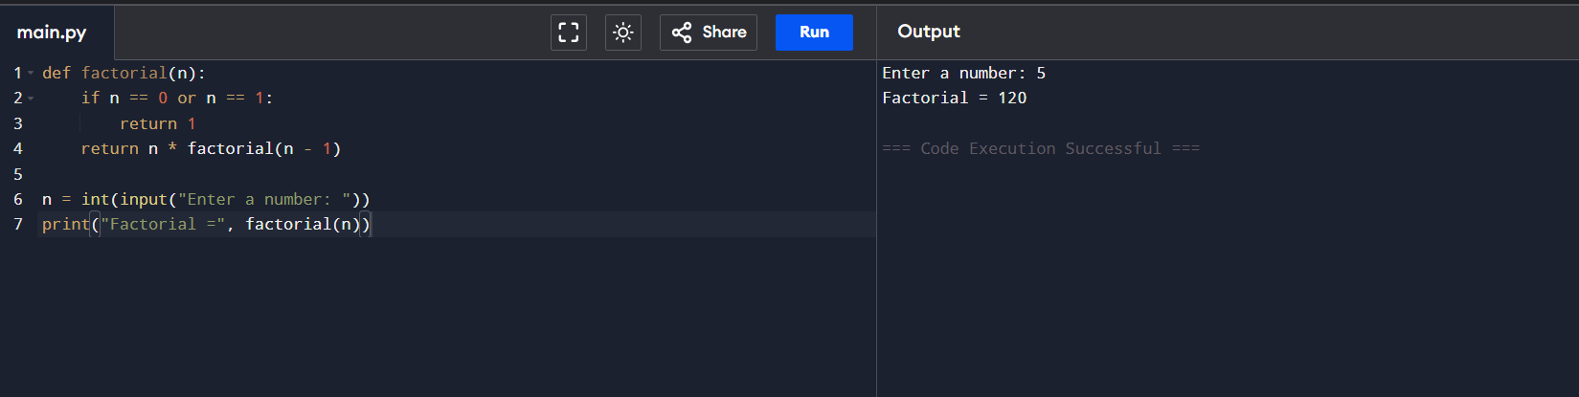
RECURSIVE METHOD

Experiment 4: Fibonacci Series
- Objective: To analyze recursive vs iterative Fibonacci generation.
- Problem Statement: Generate first n Fibonacci numbers.
- Sample Input: n = 6
- Sample Output: [0, 1, 1, 2, 3, 5]
- Complexity: Iterative O(n), Recursive naïve O(2n), Recursive with memoization O(n)
- Explanation: Illustrates exponential recursion vs efficient iteration.
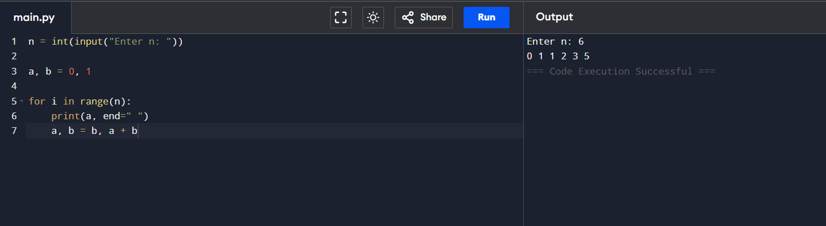
ITERATIVE METHOD

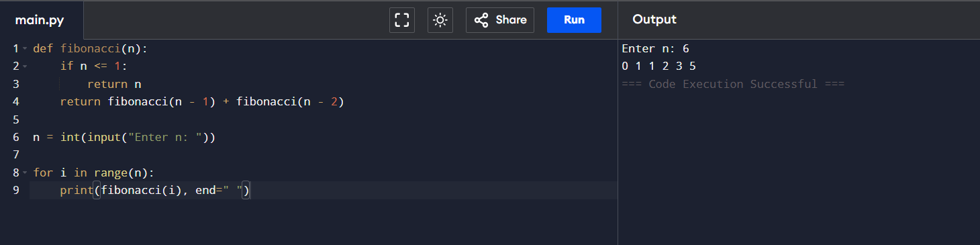

Experiment 5: Matrix Multiplication
- Objective: To analyze nested loop complexity.
- Problem Statement: Multiply two matrices using loops.
- Sample Input: A=[[1,2],[3,4]], B=[[5,6],[7,8]]
- Sample Output: [[19,22],[43,50]]
- Complexity: O(n3)
- Explanation: Shows cubic growth due to nested loops.
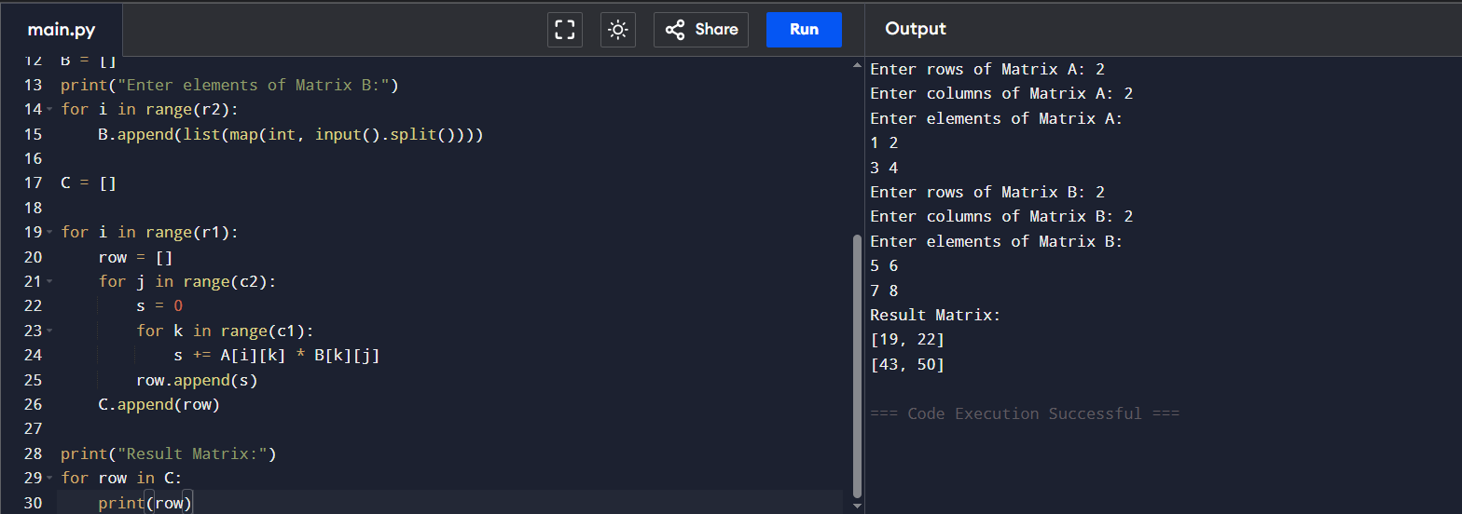

Experiment 6: Merge Sort
- Objective: To analyze divide-and-conquer sorting.
- Problem Statement: Implement merge sort.
- Sample Input: [38, 27, 43, 3, 9, 82, 10]
- Sample Output: [3, 9, 10, 27, 38, 43, 82]
- Complexity: Always O(nlog⁡n)
- Explanation: Demonstrates guaranteed efficiency of divide-and-conquer.
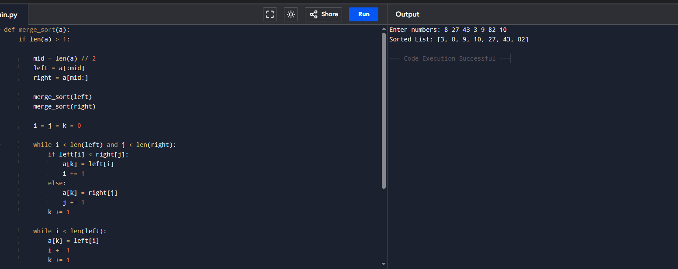

Experiment 7: Quick Sort
- Objective: To analyze recursive quick sort.
- Problem Statement: Implement quick sort.
- Sample Input: [10, 7, 8, 9, 1, 5]
- Sample Output: [1, 5, 7, 8, 9, 10]
- Complexity: Ω: O(nlog⁡n), O: O(n2), Θ: Θ(nlog⁡n)
- Explanation: Shows how pivot choice affects performance.

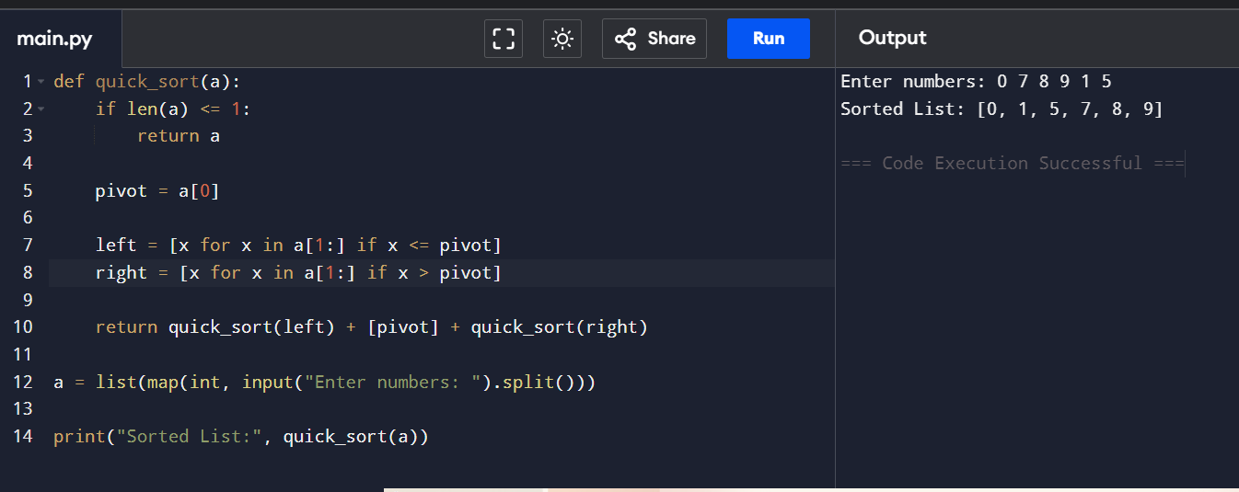

Experiment 8: Tower of Hanoi
- Objective: To analyze exponential recursion.
- Problem Statement: Solve Tower of Hanoi for n disks.
- Sample Input: n = 3
- Sample Output: Sequence of moves.
- Complexity: O(2n)
- Explanation: Illustrates exponential growth in recursive calls.
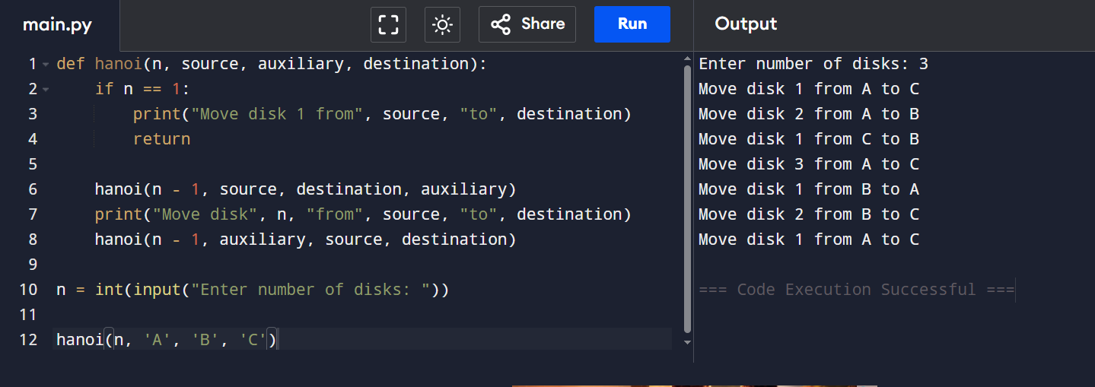

Experiment 9: GCD (Euclidean Algorithm)
- Objective: To analyze recursive GCD.
- Problem Statement: Implement Euclidean algorithm.
- Sample Input: a=48, b=18
- Sample Output: 6
- Complexity: O(log⁡n)
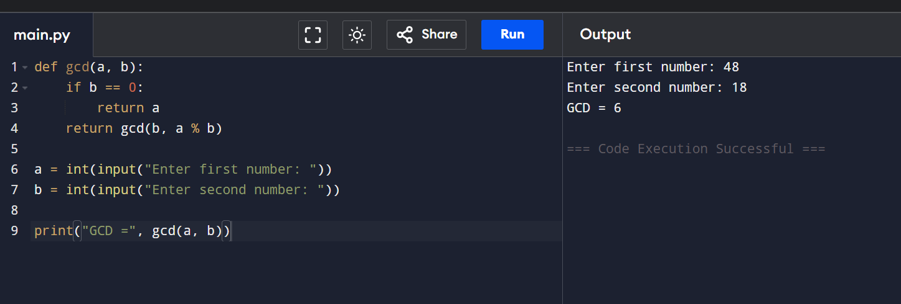
- Explanation: Shows efficient recursion with logarithmic complexity.

Experiment 10: Insertion Sort
- Objective: To analyze iterative sorting.
- Problem Statement: Implement insertion sort.
- Sample Input: [12, 11, 13, 5, 6]
- Sample Output: [5, 6, 11, 12, 13]
- Complexity: Ω: O(n), O: O(n2), Θ: Θ(n2)
- Explanation: Demonstrates input sensitivity (sorted vs unsorted).
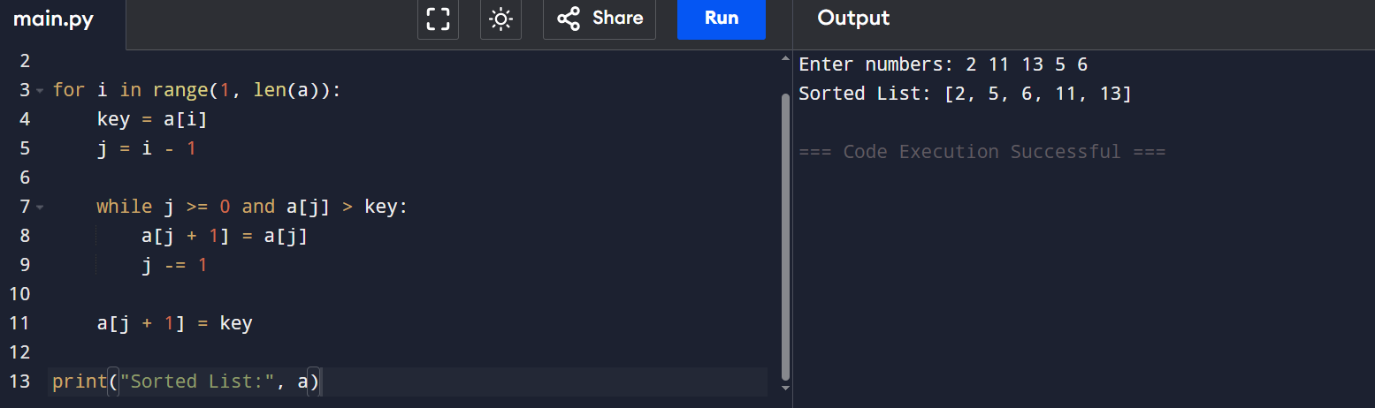

Experiment 11: Heap Sort
- Objective: To analyze heap-based sorting.
- Problem Statement: Implement heap sort.
- Sample Input: [4, 10, 3, 5, 1]
- Sample Output: [1, 3, 4, 5, 10]
- Complexity: Always O(nlog⁡n)
- Explanation: Consistent performance using heap structure.
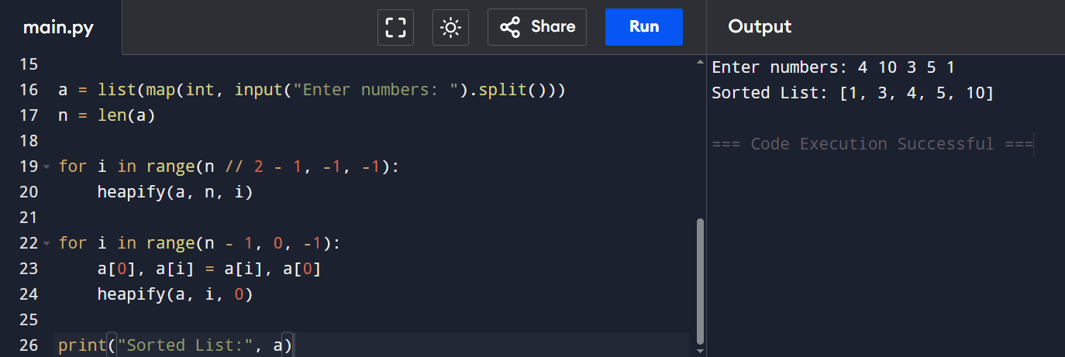

Experiment 12: Counting Inversions
- Objective: To analyze modified merge sort.
- Problem Statement: Count inversions in an array.
- Sample Input: [2, 4, 1, 3, 5]
- Sample Output: 3
- Complexity: O(nlog⁡n)
- Explanation: Shows divide-and-conquer applied beyond sorting.

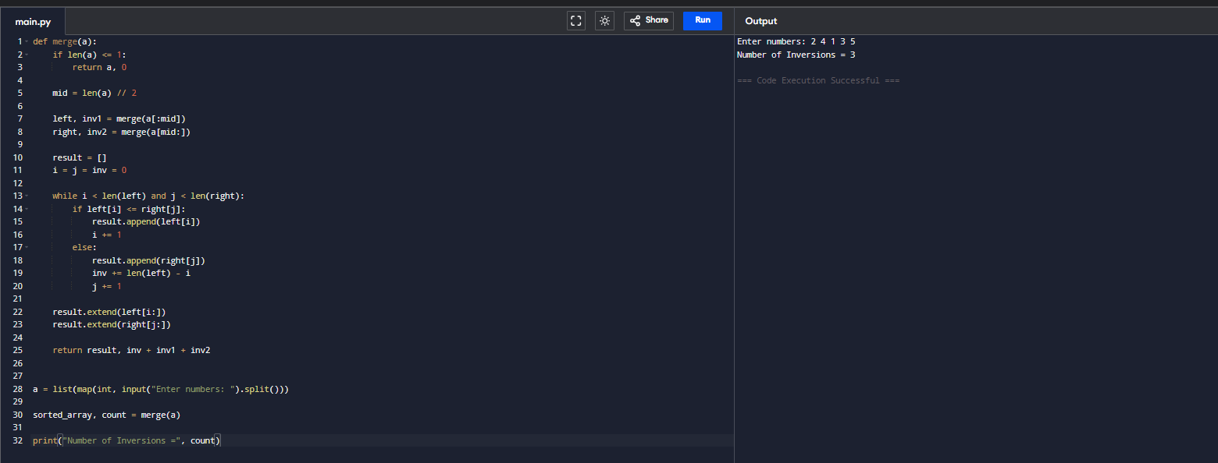

Experiment 13: Maximum Subarray Sum
- Objective: To compare Kadane’s vs divide-and-conquer.
- Problem Statement: Find maximum subarray sum.
- Sample Input: [-2, -3, 4, -1, -2, 1, 5, -3]
- Sample Output: 7
- Complexity: Kadane’s O(n), Divide & Conquer O(nlog⁡n)
- Explanation: Highlights efficiency differences between approaches.
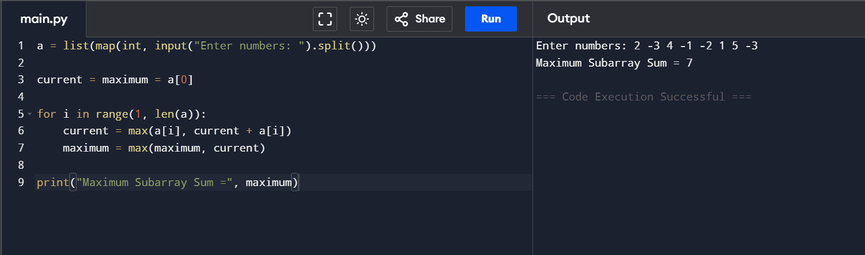

Experiment 14: Exponentiation
- Objective: To compare iterative vs recursive fast power.
- Problem Statement: Compute xn.
- Sample Input: x=2, n=10
- Sample Output: 1024
- Complexity: Iterative O(n), Recursive fast power O(log⁡n)
- Explanation: Shows how recursion reduces complexity.
ITERATIVE METHOD
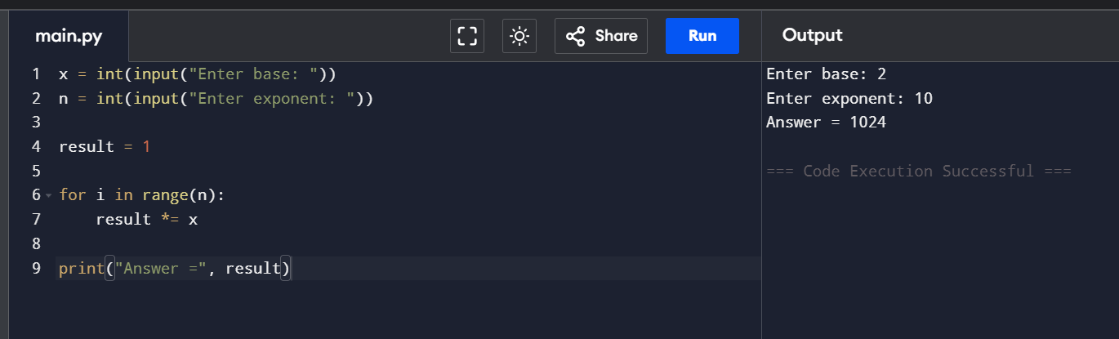

RECURSIVE METHOD

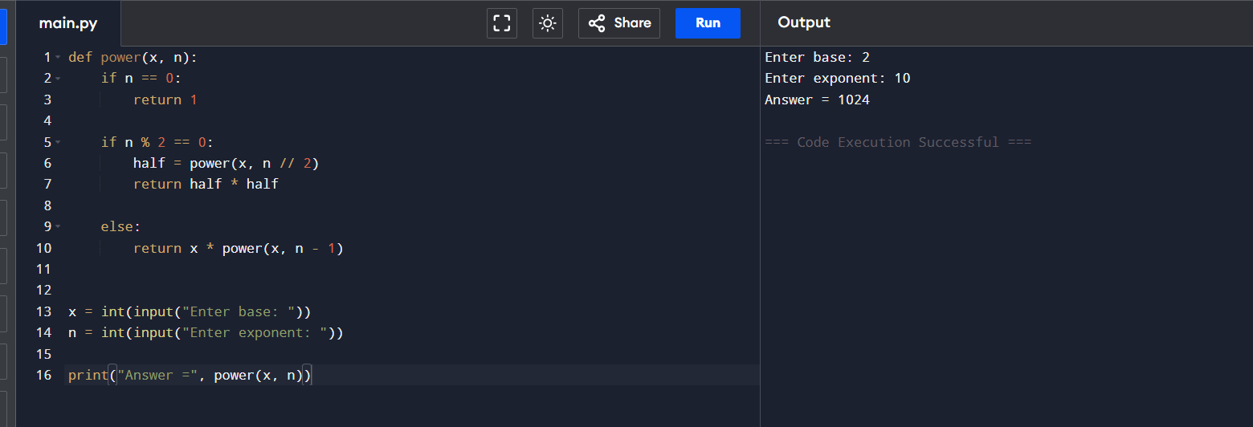

Experiment 15: Closest Pair of Points
- Objective: To analyze brute force vs divide-and-conquer.
- Problem Statement: Find closest pair of points in 2D.
- Sample Input: [(1,2), (4,5), (7,8), (3,1)]
- Sample Output: Closest pair (1,2)-(3,1), Distance = √5
